EXPERIMENT : 5 (A) Simulation and Performance Evaluation of RFID/NFC-Based Device Identification and IoE Data Integration using Node-RED and MQTT

Objective :
To simulate RFID/NFC-based device identification and integrate the identification data into an Internet of Everything (IoE) system using MQTT and Node-RED for real-time monitoring and visualization.

Procedure :
- Install and configure Node.js, Node-RED, and the Mosquitto MQTT broker.
- Simulate RFID/NFC tag scanning by generating unique device IDs.
- Configure an MQTT publisher to send device identification data to a specific topic.
- Configure Node-RED with MQTT input and processing nodes to receive and process the messages
- Validate the device ID and display the identification status on the Node-RED dashboard.
- Monitor message delivery, response time, and successful device identification.
Output :
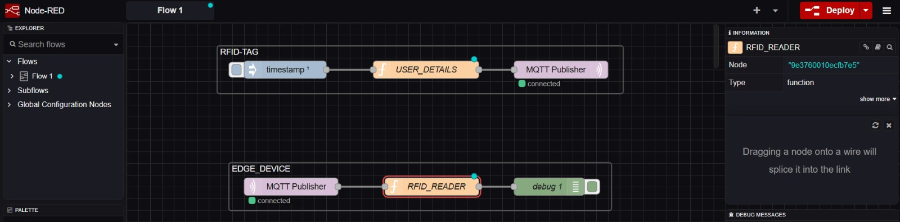
Result :
RFID/NFC-based device identification was simulated successfully, and device data was transmitted through MQTT and processed in Node-RED for real-time monitoring and visualization.

